Course | Computer Forensic
Lab | Lab 01
Name of the Student | Maisha Khatoon
Student ID | 100899259

LAB: 01

Hexadecimal
Analyzing Digital Evidence

Objective:
- To understand that files have unique file headers based in type of file
- Installing Autospy
- To Analyze files on USB drive

Activities:
Task 1
Hexadecimal

Note: Please include a screenshot of each step. Corp your screenshot to show relevant information only. Uncropped screenshots will result in a 10% deduction from your marks.
Leaning Activities:
At the end of these activities, you should understand:
- How to determine key details related to basic file headers.
- How to search and generate report using Autospy.

1) Download and Install Winhex software on your computer.
(http://www.winhex.com/winhex/hex-editor.html)
2) Download the Lab1_files.zip (week2) from DC Connect.
3) Open each file in Winhex.
4) Using a chart of file signatures determine what type the file are listed in the following URL and fill the following table:
http://en.wikipedia.org/wiki/List_of_file_signatures

File_Name | Hex Signature | File extension | offset | Description
File1 | 50 4B 03 04 | ZIP | 0 | zip file format and formats based on it, such as EPUB, JAR, ODF, OOXML
File2 | 25 50 44 46 | PDF | 0 | PDF Document
File3 | 42 4D | BMP DIB | 0 | BMP file, a bitmap format used mostly in the Windows world
File4 | 47 49 46 38 | GIF | 0 | Image file encoded in the Graphics Interchange Format (GIF)
File5 | D4 C3B2 A1 | PCAP | 0 | Libpcap File Format
File6 | 25 50 44 46 | PDF | 0 | PDF Document
File7 | 47 49 46 38 | GIF | 0 | Image file encoded in the Graphics Interchange Format (GIF)
File8 | 4D 5A | exe  scr  sys  dll  fon  cpl  iec  ime  rs  tsp  mz | 0 | DOS MZ executable and its descendants (including NE and PE)

Task 2

Before doing the next task, you need to download Autopsy for Windows, a free forensics tool from Sleuth Kit. Download Autopsy from https://www.autopsy.com/download/, and then install it. For detailed information on using Autopsy, http://sleuthkit.org/autopsy/docs/user-docs/4.17.0/. For an explanation of the user interface, see http://sleuthkit.org/autopsy/docs/user-docs/4.17.0/uilayout_page.html.

In the following steps, you analyze George Montgomery’s USB drive. The first task is to configure Autopsy for a new case and analyze the image file of George Montgomery’s USB drive. To perform the analysis, follow these steps:

2.1 Create a “C:\Work\Chap01\Chapter” folder

2.2. Download “Ch01InChap01.dd” file in C:\Work\Chap01\Chapter folder. Start Autopsy for Windows.

2.3 In Autopsy’s main window, click the Create New Case button. In the New Case Information window, enter InChap01 in the Case Name text box (see Figure 1-12), and click Browse next to the Base Directory text box. Navigate to and click your work folder. Make sure the Single-user option button is selected for Case Type, and then click Next.

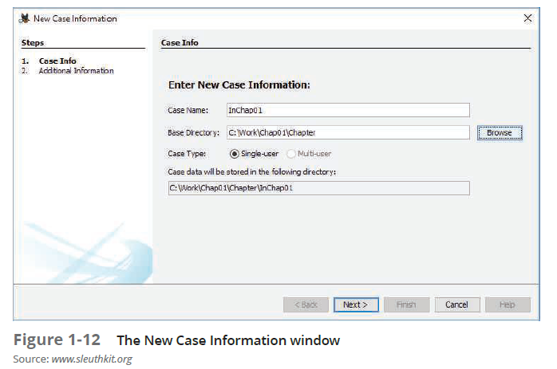

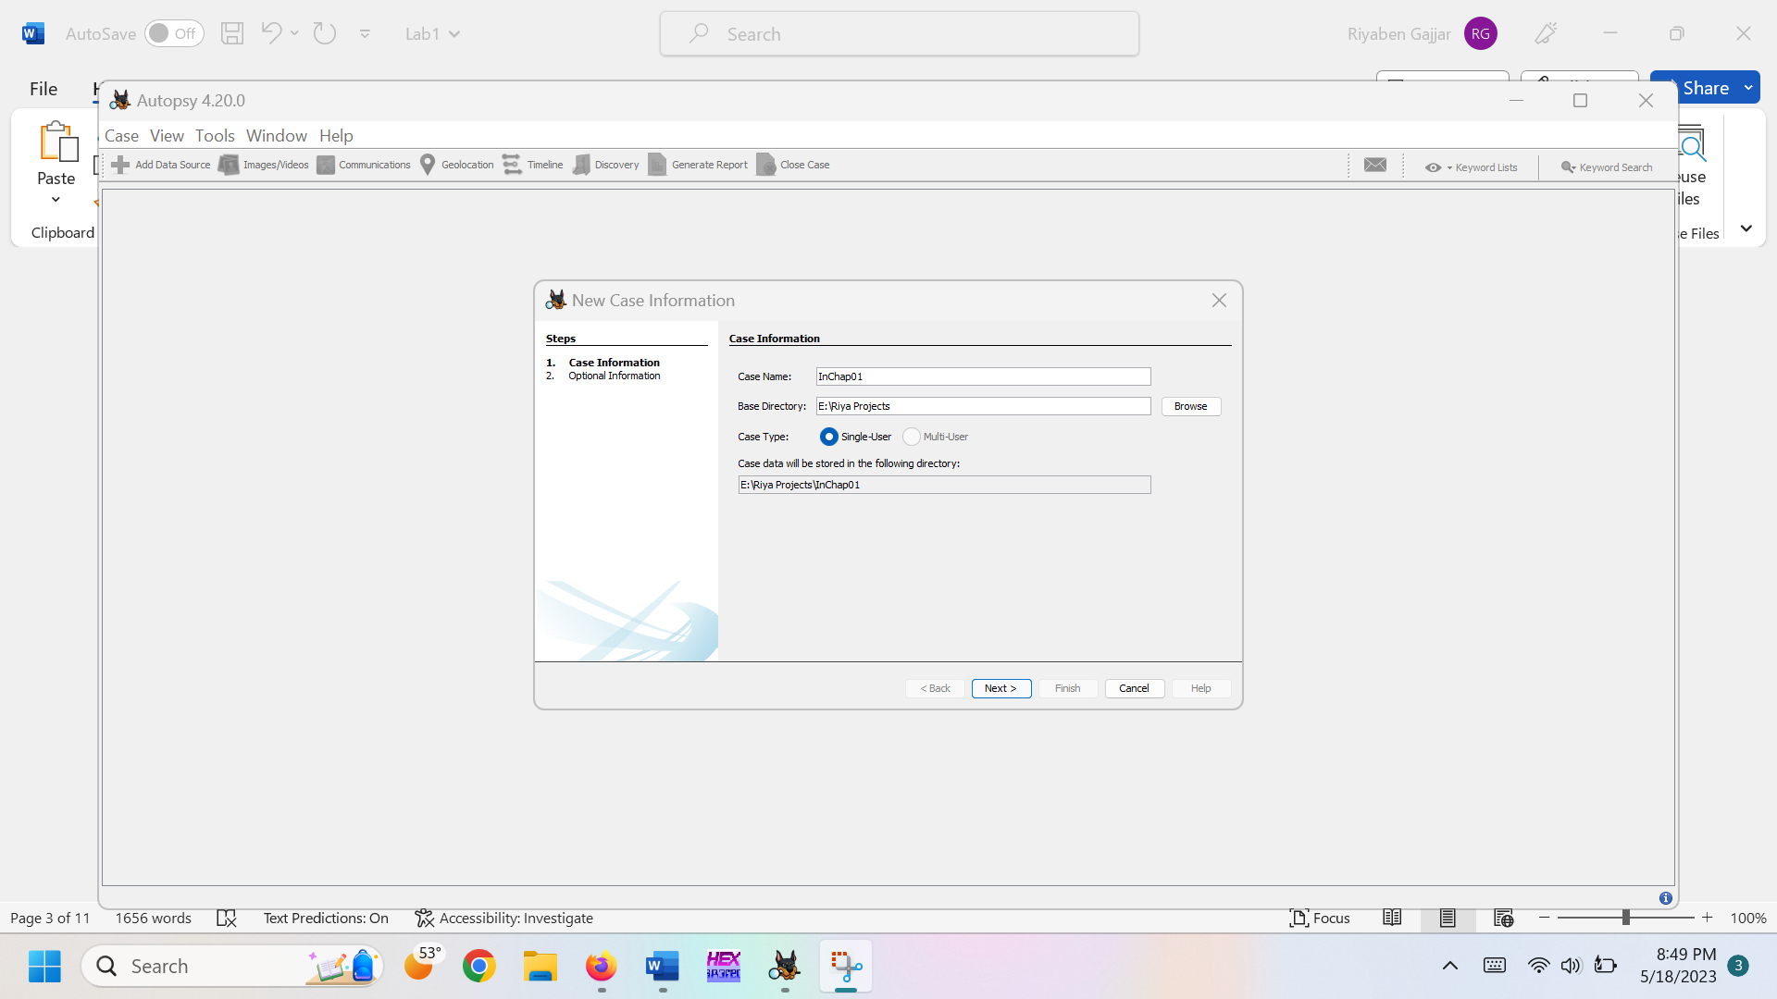

2.4 In the Add Data Source window, select Disk Image or VM File (see Figure 1-13), and then click Next.

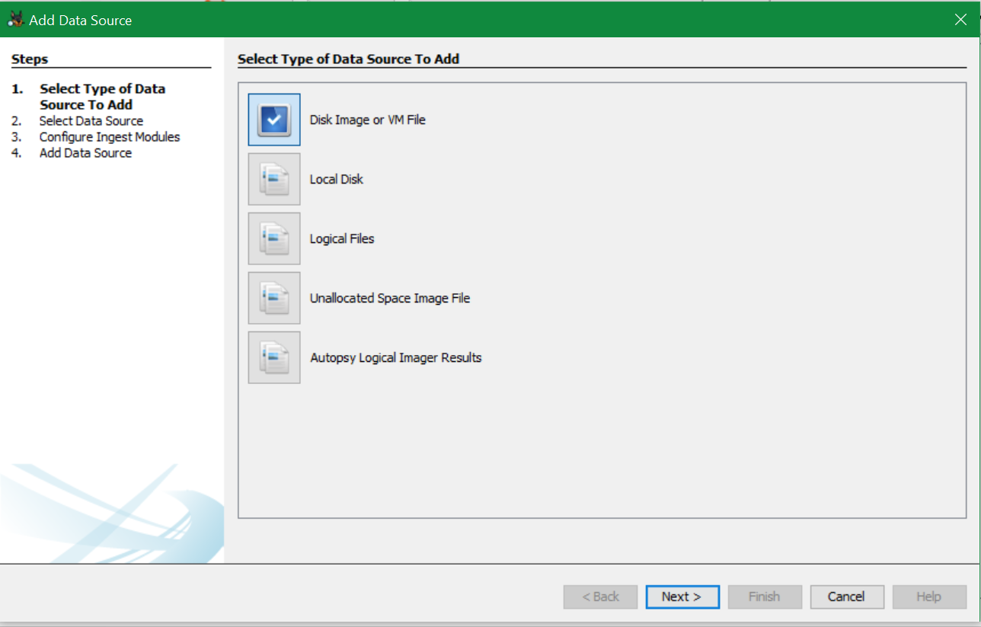

Figure 1-13

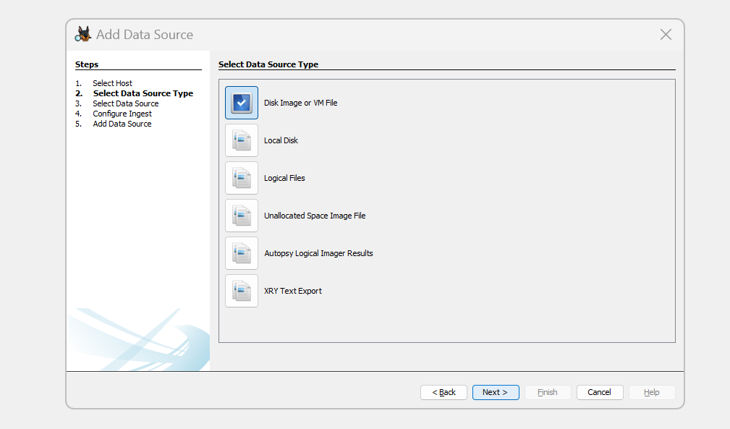
2.5 In the Select Data Source window (see Figure 1-14). Click the Browse button next to the “Browse for an image file” text box, navigate to and click your work folder and the Ch01InChap01.dd file, and then click Open. Click Next.

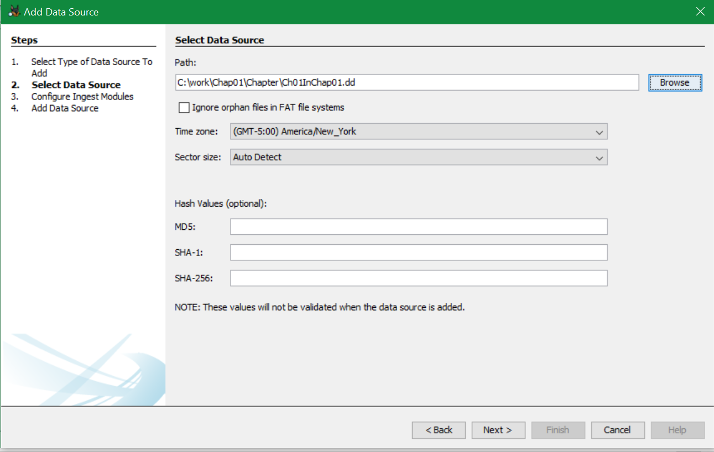
Figure 1-14

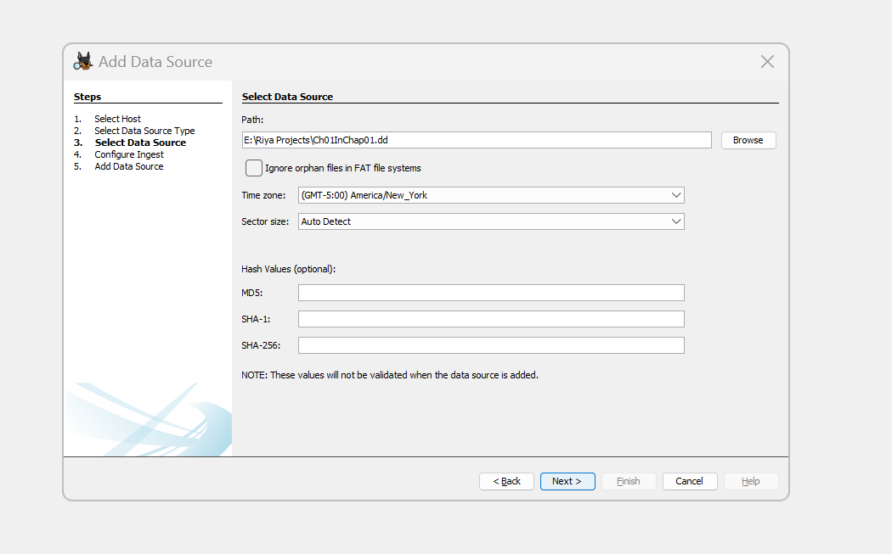

2.6 Keep the default settings in the Configure Ingest Modules window (Figure 1-14-1). Click Next and then Finish.
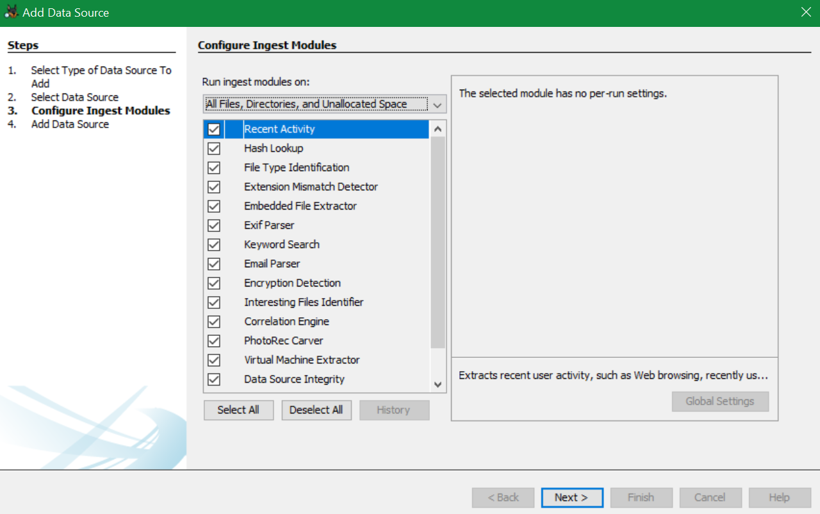
Figure 1-14-1

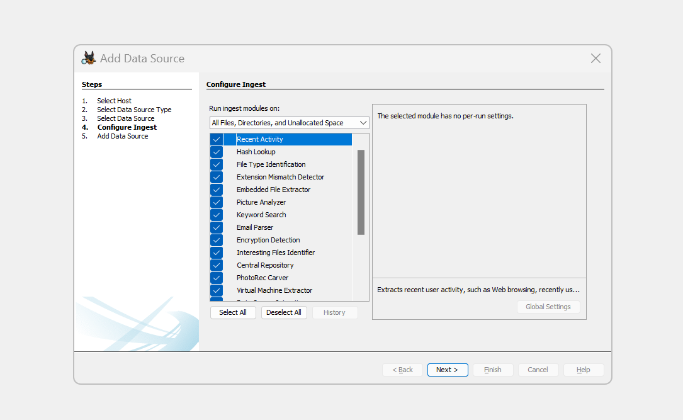

2.6.1. Next, follow these steps to display the contents of the acquired data:
In the Tree Viewer pane on the left, click to expand Views, File Types, By Extension, and Documents (see Figure 1-15).

2.6.2. Under Documents, click Office. In the Result Viewer (upper-right pane), click the first file, Billing Letter.doc, to display its contents in the Content Viewer (lower-right pane).

2.6.3. Right-click Billing Letter.doc, point to Tag File, and click Tag and Comment.

2.6.4. In the Create Tag dialog box, click the New Tag Name button shown in Figure 1-16. In the New Tag section, type Recovered Office Documents in the Tag Name text box, click OK, and then click OK again.

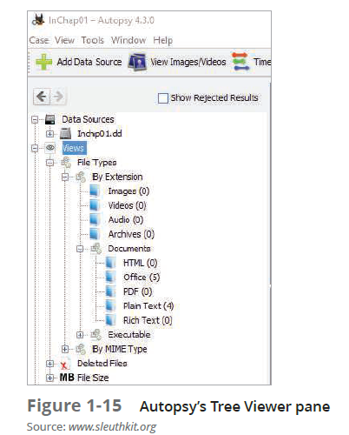

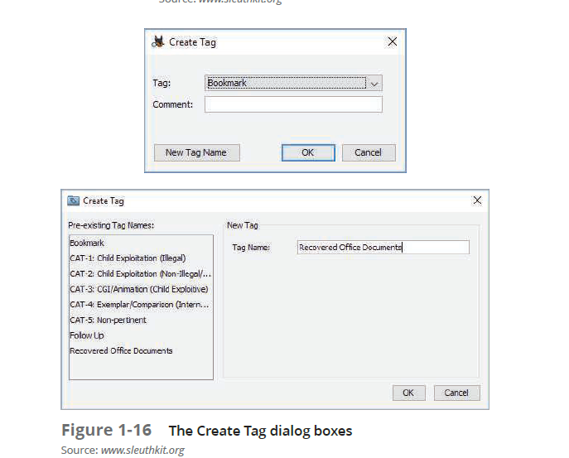

2.6.5 In the Result Viewer pane, Ctrl+click Billing Letter.doc, Income.xls, Regrets.doc, f0000000.doc, and f0000049.doc to select these files, and then release the Ctrl key. Right-click the highlighted files shown in Figure 1-17, point to Tag File and then Quick Tag, and then click Recovered Office Documents.

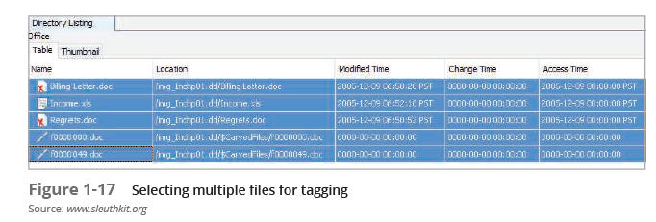

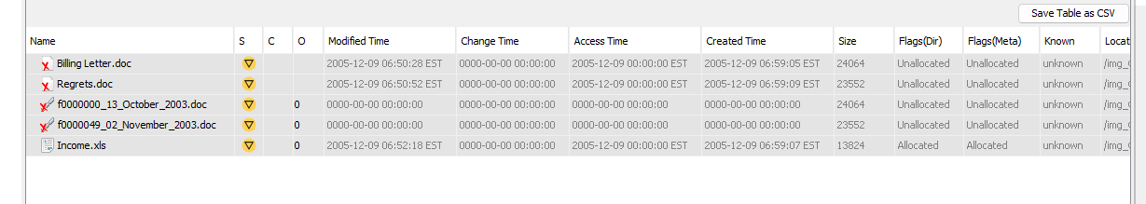

2.6.6 Under Documents in the Tree Viewer pane, click Plain Text to display more recovered files.

2.6.7. In the Result Viewer pane, select the files listed in Step 2.6.6 again, right-click the selection, point to Add File Tag File and then click Follow Up. Leave Autopsy running for the next activity.

The next step is analyzing the data and searching for information related to the complaint. Data analysis can be the most time-consuming task, even when you know exactly what to look for in the evidence. The method for locating evidentiary artifacts is to search for specific known data values. Data values can be unique words or nonprintable characters, such as hexadecimal codes. There are also printable character codes that can’t be generated from a keyboard, such as the copyright (©) or registered trademark (™) symbols. Many digital forensics programs can search for character strings (letters and numbers) and hexadecimal values, such as 0xA9 for the copyright symbol or 0xAE for the registered
trademark symbol. All these searchable data values are referred to as “keywords.

With Autopsy, you can search for keywords of interest in the case. For this case, you need to find any files associated with George Montgomery. Follow these steps to search for any reference to the name “George”:

    - Click the Keyword Search button at the far upper right, type George in the text box (see Figure 1-18), and then click Search.”
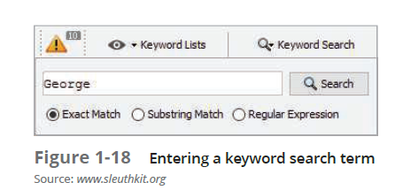

2.6.9 In the Result Viewer pane, a new tab named Keyword search 1 opens. Click each file to view its contents in the Content Viewer (see Figure 1-19). Look for files containing the name “George.”

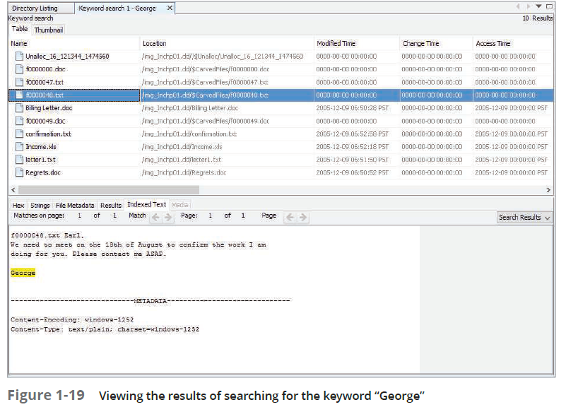

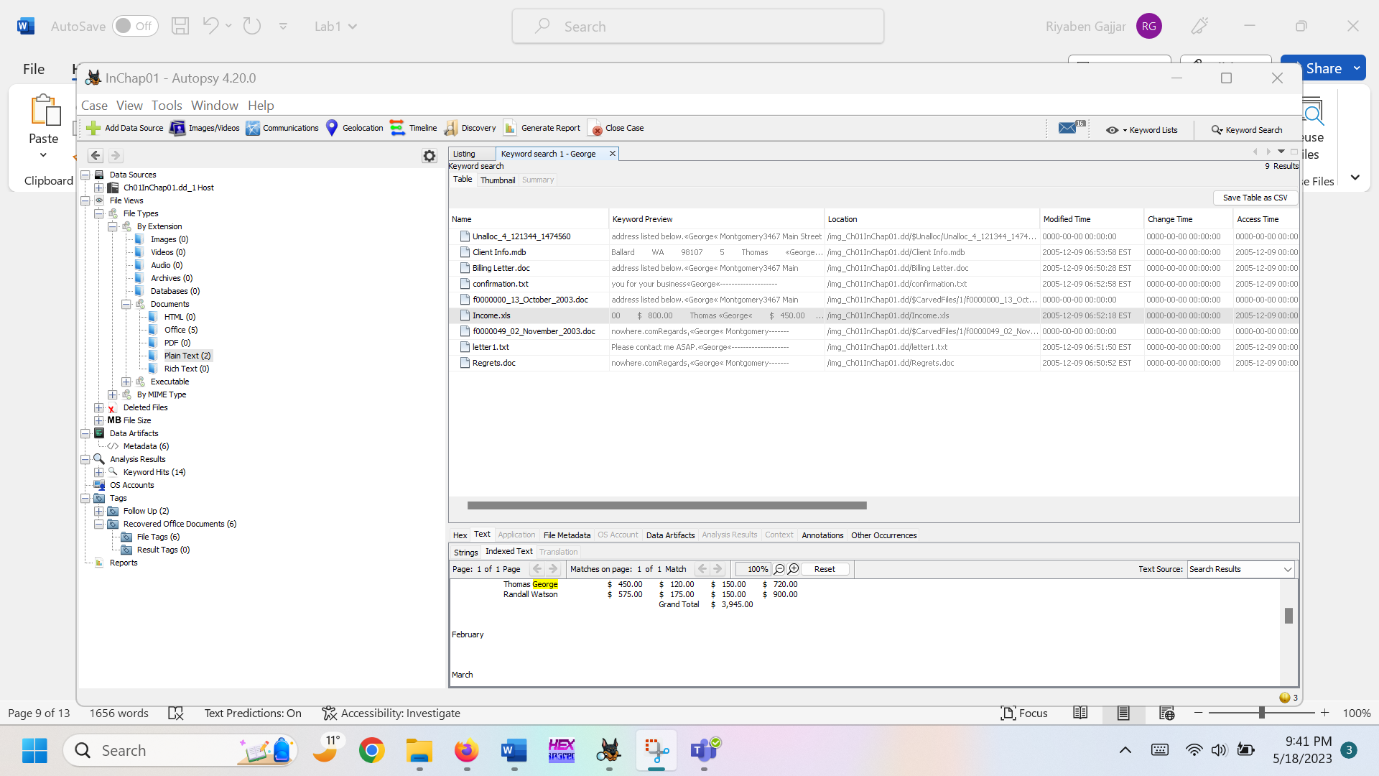

2.7.0 Click the Keyword Lists button at the far upper right, click the Email Addresses check box, and then click Search.

2.7.1 . In the Result Viewer pane, a new tab named Keyword search 2 opens. Click each file to view its contents in the Content Viewer pane and examine all e-mail addresses found in the search. Leave Autopsy running so that you can learn about more of its features in the next section.

Some Additional Features of Autopsy
If you find a file of interest that displays binary (nonprintable) data in the Content Viewer, there are six available viewing options in Autopsy: Hex, Strings, File Metadata, Results, Indexed Text, and Media. To view an unallocated sector for its hexadecimal values, click the Hex tab in the Content Viewer, as shown in Figure 1-20.

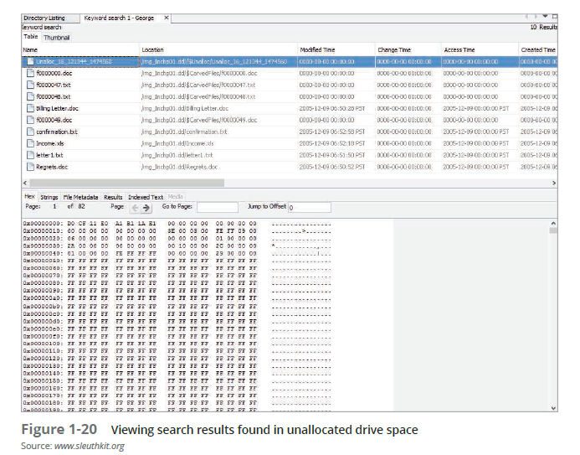

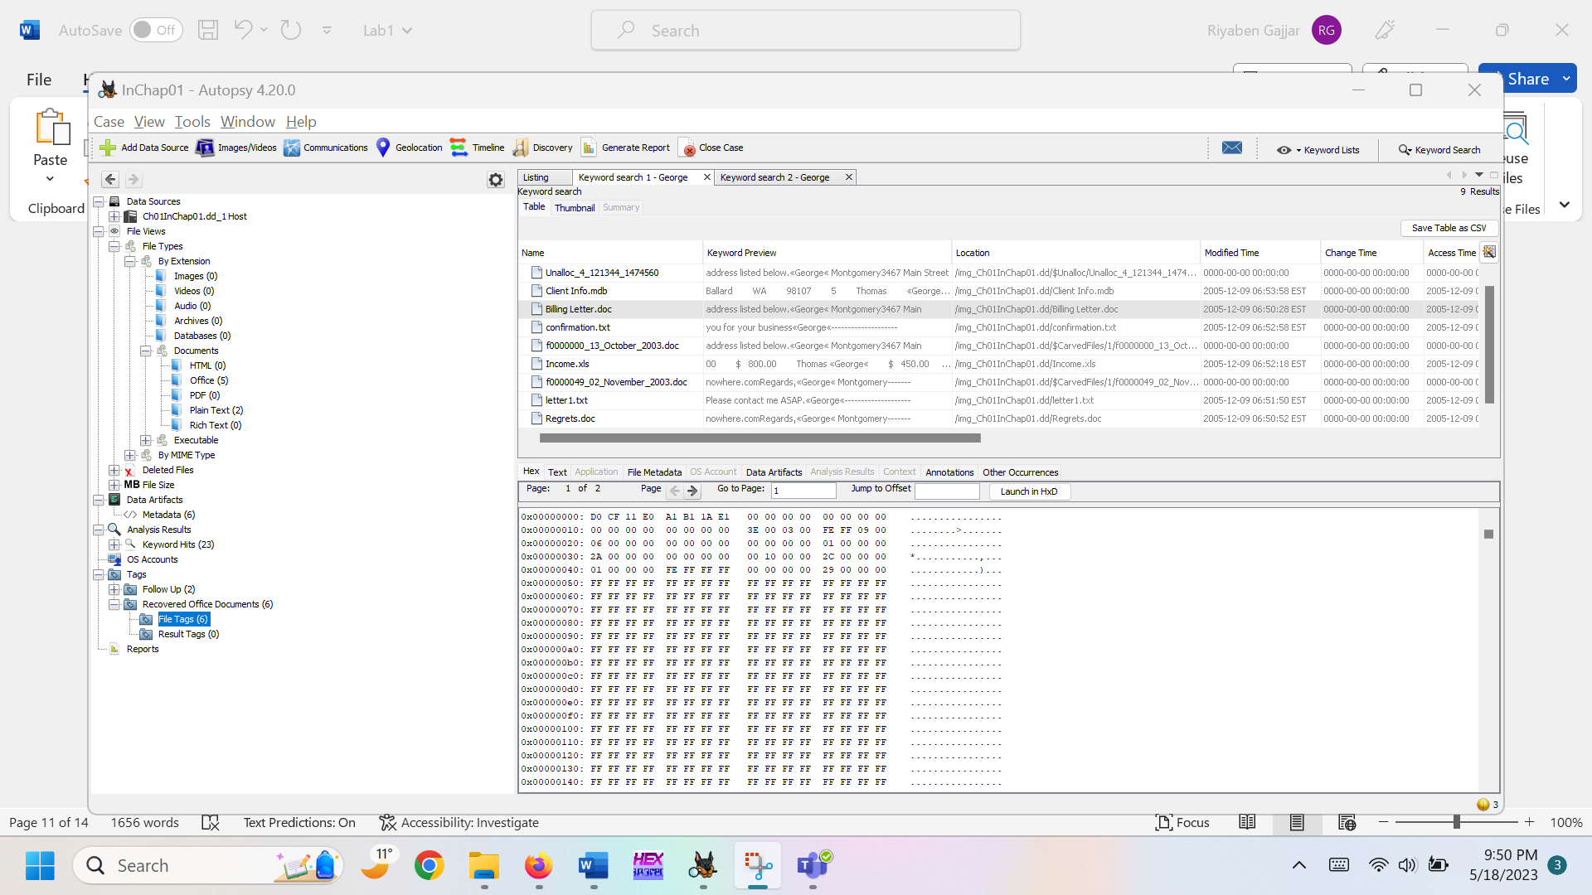

If you want to examine an Office file, such as an Excel spreadsheet, right-click the file and click Open in External Viewer. To use this option, you must have the external viewer’s software installed on your computer. To export a file from Autopsy, select it, and then right-click the file and click Extract File. In the Save dialog box that opens, you can copy the file to a work folder.

Autopsy’s Report Generator
Autopsy has several styles of reports, including a plain text file, an HTML Web page with links to artifacts, and an Excel spreadsheet. To generate a report, you can follow this general procedure:

2.7.2. If you exited Autopsy, start it again, and click Open Recent Case. Click InChap01 and then click Open in the Recent Case window. In Autopsy’s main window, click the Generate Report button at the top.

2.7.3 In the Generate Report window, select the report format you want in the Report Modules section (see Figure 1-21). The Results - HTML option, for example, produces a linkable Web page with tagged artifacts, and the Files - Text option creates a plain text output file. When you’re finished, click Next.

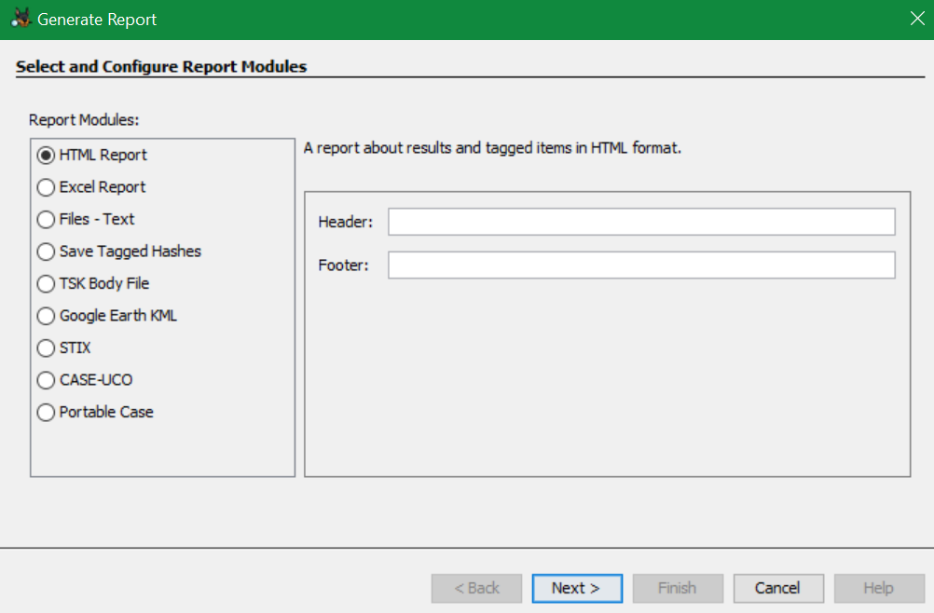
Figure 1-21

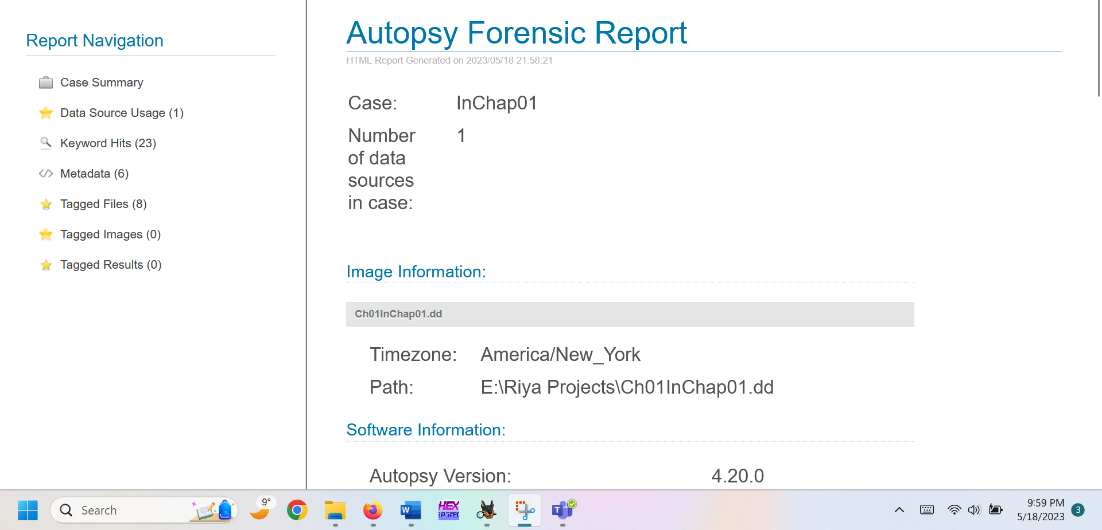

Task 3
The case in this project involves a suspicious death. Joshua Zarkan found his girlfriend’s dead body in her apartment and reported it. The first responding law enforcement officer seized a USB drive. A crime scene evidence technician skilled in data acquisition made an image of the USB drive with FTK Imager and named it C1Prj01.E01. Following the acquisition, the technician transported and secured the USB drive and placed it in a secure evidence locker at the police station. You have received the image file from the detective assigned to this case. He directs you to examine it and identify any evidentiary artifacts that might relate to this case. To process this case, follow these steps to evaluate what’s on the image of the USB drive:

Download C1Prj01.E01 (week2) from DC Connect

3.1. Start Autopsy for Windows, and click the Create New Case icon. In the New Case Information window, enter C1Prj01 in the Case Name text box, and click Browse next to the Base Directory text box. Navigate to and click your work folder, and then click Next.

3.2. In the New Case Information window, type C1Prj01 in the Case Number text box and your name in the Examiner text box, and then click Finish.

3.3. In the Add Data Source window, click Image File or VM File and click next, Click the Browse button next to the “Browse for an image file” text box, navigate to and click your work folder and the C1Prj01.E01 file (Figure 1-22), and then click Open. Click Next.

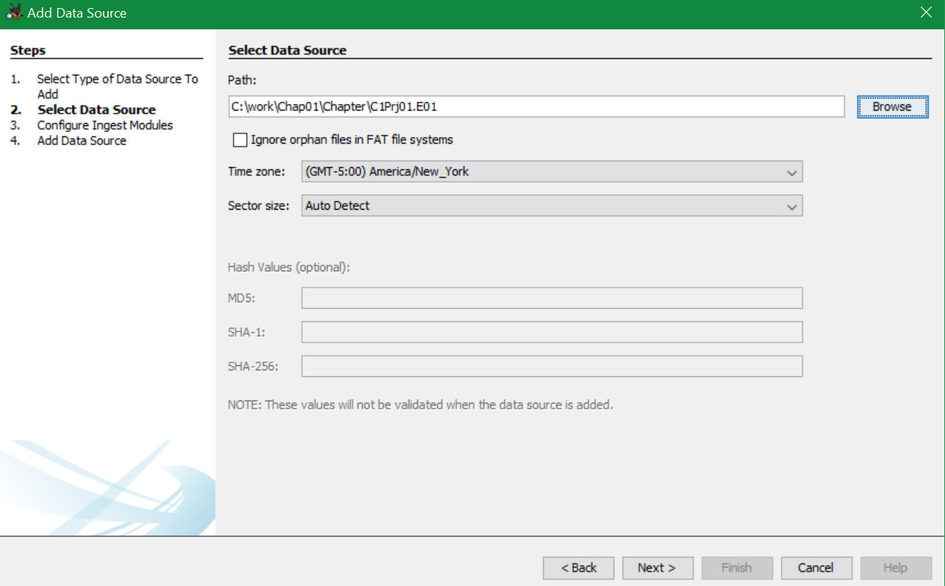
Figure 1-22

3.4. In the Configure Ingest Modules window, click Select All. Click Next and then Finish.

3.5. In the Tree Viewer pane, expand Views, File Types, By Extension, and Documents.

3.6. Examine each subfolder under Documents. Determine which folder might contain files of interest to this case.

3.7. If you found any files related to the case, select the files as a group, right-click the selection, and click Extract File(s). In the Save dialog box, click Save to save the files automatically in Autopsy’s case subfolder: Work \Chap01\Projects\C1Prj01\Export.

Reflective statements (end-of-exercise):
You should reflect on these questions:

- Briefly describe the triad that makes up computer security.

The triad which makes up computer security is often said as CIA Triad which is known as Confidentiality, integrity, and availability. Confidentiality concentrates on ensuring that information is protected from unauthorized access. Integrity refers to the accuracy of data. Availability focuses that resources and information are accessible when needed.

- What are some of the most common types of private-sector computer crime?
Data breaches, Ransomware attacks, Social Engineering

- Why should the evidence media be write-protected?
To make sure that data is not modified.

References

https://asecuritysite.com/forensics/magic

